E-Commerce Dashboard

Name: Mehlaqa Hussaini

Program: Masters’ Program in Business Analysis

Subject: Business Analytics Using Excel

Scenario

I had data of an E-commerce company that had more than 5000 entries. I created a dashboard to analyse the sales based on various product categories month wise and Region wise.

Steps for creating working sheet that will be used in creating Dashboard

Step 1:

Firstly, I created an Excel sheet where I created a table that contains Month wise sales and profits calculation of different product items and fetched the data using **SUMIFS** mathematical function fromour data that is in different tab in the existing worksheet.

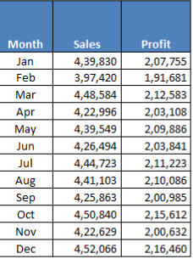

=SUMIFS ('Data to be used'!$H$2:$H$51291,'Data to be used'!$U$2:$U$51291,'working data'!$A$4,'Data to be used'!$F$2:$F$51291,'working data'!$O$5)

This Formula contains sales column as sum_range, criteria_range1 as month_column, criteria1 as month_name, criteria_range2 as product_category and criteria2 as form control(so that it will show the selected date and product sales)

Step 2:

Side by side, I created another table which shows region wise sales of different product categories.

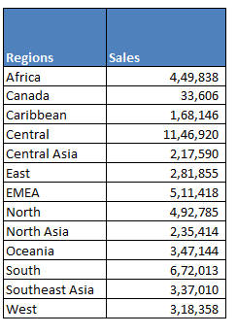

=SUMIFS('Data to be used'!H2:H51291,'Data to be used'!T2:T51291,'working data'!E4,'Data to be used'!F2:F51291,'working data'!O5)

In the Sumifs formula above I selected Sales column as Sum_range, Region column as criteria_range1 and particular region as criteria 1 and product category column as criteria_range 2 and form control (selected by user) as criteria 2.

Step 3:

In third step, I created two separate tables for histogram that contains Bins range (Age range)and Maximum of each bin and other table contains Bins and frequency of occurrence. Frequency of occurrence table is used in creating histogram

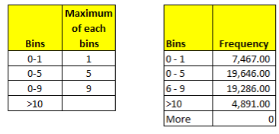

Step 4:

The table that is depicted below is for forms control, when I created combo box in my Ecommerce dashboard. I Used this list for dropdown. Two cells to the right side of the given table are for form control. Cell showing 3 depicts that user has selected product third that is fashion in the dashboard to know about its performance.

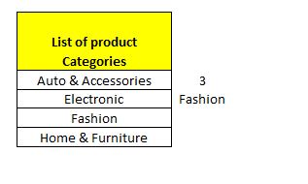

Compete view of the working sheet

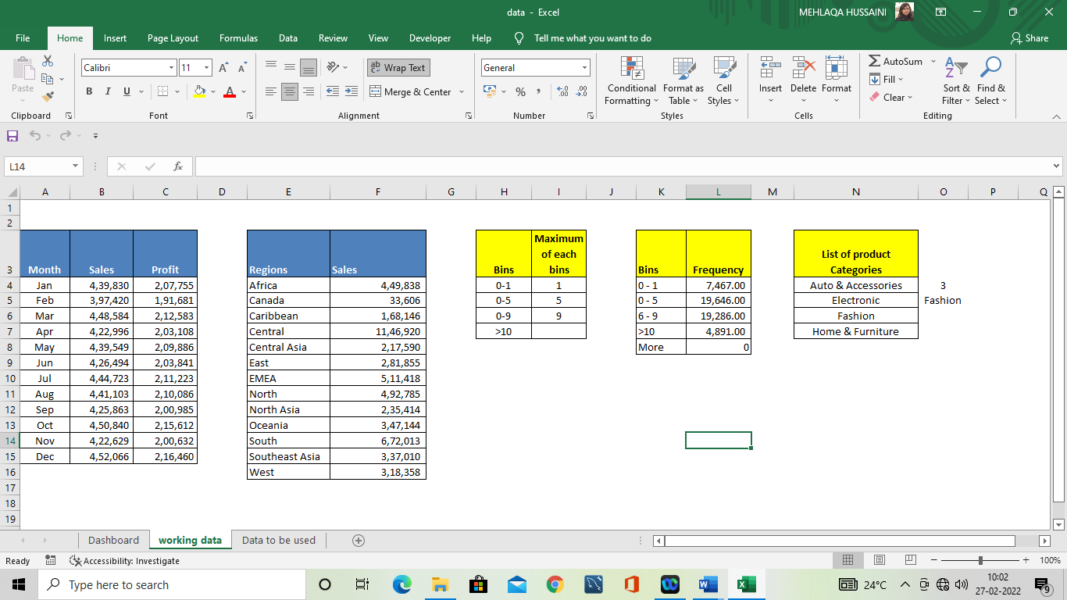

Steps included while creating dashboard

Step 1:

The picture given below contains combo box that allow a user to select a category form dropdown list and see its performance like how much a particular product has been sold out, in what quantity and how much profit it has gained in its sale etc.

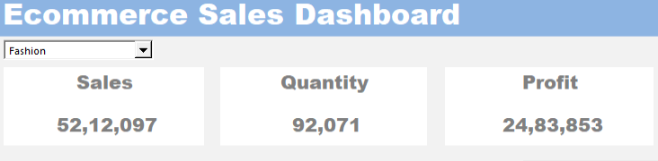

This is the form control menu

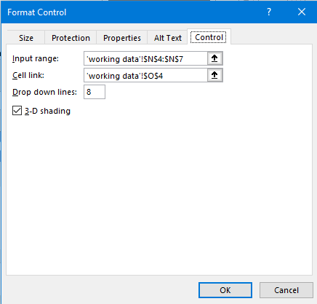

In the input range above, I selected the range of product that I created in the working sheet and in cell link I selected a blank cell right side of the product list that will show the serial no of selected product.

The buttons like cells that contains sale, quantity and profit detail of the selected product, I applied **Sumifs** formula since I had multiple condition to fetched data.

To find out total sales of a product category selected by a user

=SUMIF('Data to be used'!$F$2:$F$51291,'working data'!$O$5,'Data to be used'!$H$2:$H$51291)

To find out total Quantity of a product category selected by a user

=SUMIF('Data to be used'!F2:F51291,'working data'!O5,'Data to be used'!I2:I51291)

To find out total Profit of a product category selected by a user

=SUMIF('Data to be used'!F2:F51291,'working data'!O5,'Data to be used'!K2:K51291)

Step 2:

Second step in creating a dashboard was creation of Bar chart that should be connected to the combo box and should depict the monthly sales of the selected product category.

I selected the table that I created in working sheet and placed this chart in the dashboard.

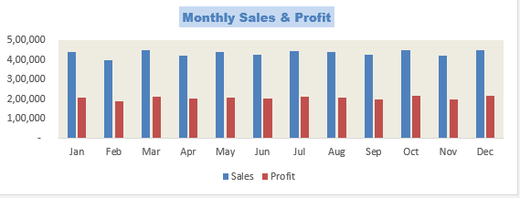

Step 3:

Next step of this dashboard is, depiction of region wise Sales in the form of bar chart. For this chart I selected the region wise table that I created in the working sheet.

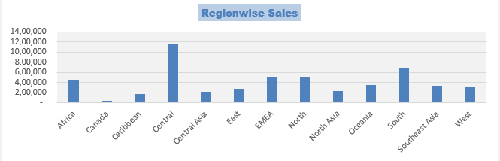

Step 4:

Final step includes, A histogram that depicts the Age wise projection and its frequency of occurrence.

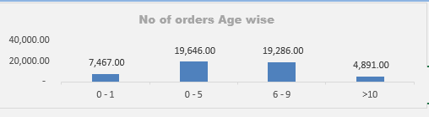

Final view of the Dashboard

It is a very interactive and user-friendly dashboard that let you everything about a huge data in just one click.

When a user selects fashion category from the combo box, this dashboard will show you each and everything about that product. You will see monthly sales and profit and region wise sales of that particular product in charts as well.

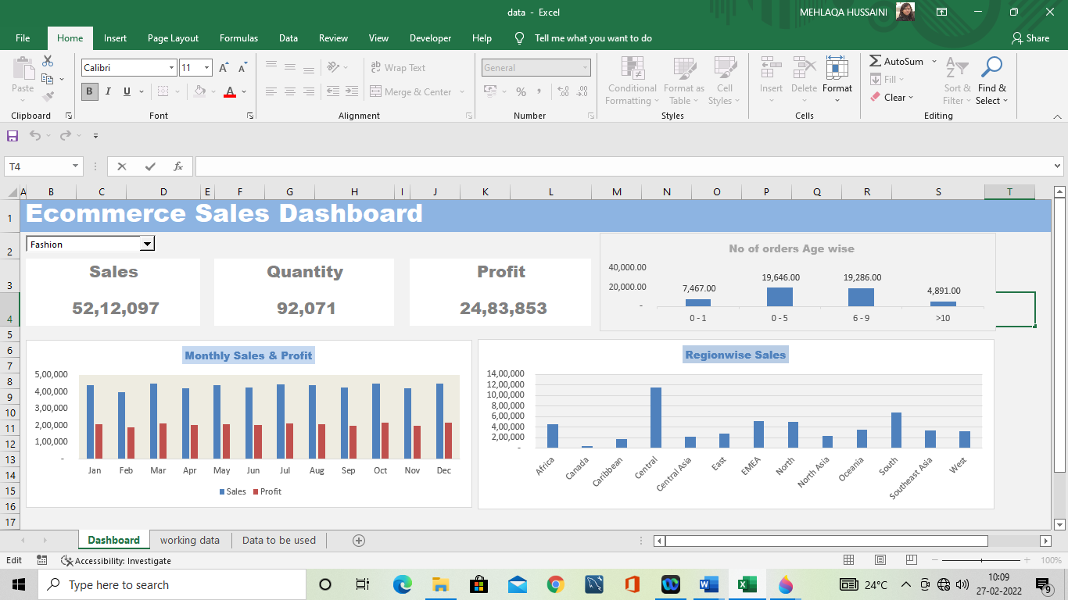

Thank You